

International School

**Capstone Project 1**

*CMU-SE 450*

**DATABASE DESIGN**

*Version: 2.1*

*Date: 29/12/2021*

**School Connect Application**

**Submitted by:**

Nguyen Thanh Phu

Nguyen Trung Hieu

Dang Nguyen Bao Hoai

**Approved by**

Nguyen Minh Nhat

**Database Design Review Panel Representative:**

Name Signature Date

**Capstone Project 1- Mentor:**

Name Signature Date

# Project Information

|  |  |  |  |  |
| --- | --- | --- | --- | --- |
| **Project acronym** | SConA | | | |
| **Project Title** | School Connect Application | | | |
| **Start Date** | 22-Aug-2021 | **End Date** | | 18-Dec-2021 |
| **Lead Institution** | International School, Duy Tan University | | | |
| **Project Mentor & contact details** | Name: Nguyen Minh Nhat  Email: nhatnm2010@gmail.com  Tel: +84 905 125 143 | | | |
| **Scrum Master & contact details** | Name: Nguyen Thanh Phu  Email: [thangphu104@gmai.com](mailto:thangphu104@gmai.com)  Tel: +84 772 492 301 | | | |
| **Team members** | **Name** | **Email** | **Tel** | |
| Nguyen Trung Hieu | hnguyentrung20@gmail.com | +84 975 299 149 | |
| Dang Nguyen Bao Hoai | dangbhoai@gmail.com | +84 773 305 395 | |

|  |  |  |  |
| --- | --- | --- | --- |
| **DOCUMENT INFORMATION** | | | |
| **Document Title** | Database Design | | |
| **Author(s)** | Team C1SE.44 | | |
| **Role** | C1SE.44- Database Design -SConA-v2.1 | | |
| **Date** | 29-Dec-2021 | **Filename** | C1SE.44-DatabaseDesign-SConAdocx-v2.1 |
| **URL** | **https://github.com/PhuNguyenThang/Capstone1** | | |
| **Access** | Project and CMU Program | | |

**DOCUMENT APPROVALS**

The following signatures are required for the approval of this document.

|  |  |  |
| --- | --- | --- |
| Nguyen Minh Nhat  *Mentor* | Signature | Date |
| Nguyen Thanh Phu  *Scrum Master* | Signature | Date |
| Nguyen Trung Hieu  *Product owner* | Signature | Date |
| Dang Nguyen Bao Hoai  *Product owner* | Signature | Date |

REVISION HISTORY

|  |  |  |  |  |
| --- | --- | --- | --- | --- |
| **Version** | **Date** | **Comments** | **Author** | **Approval** |
| 1.0 | 25-Oct-2021 | Create a database design document | Nguyen Thanh Phu |  |
| 2.0 | 03-Nov-2021 | Update more table | Nguyen Thanh Phu |  |
| 2.1 | 29-Dec-2021 | Edit column names | Nguyen Thanh Phu |  |

Table of Contents

Project Information 2

1. Introduction 5

**1.1.** **Purpose** 5

**1.2.** **Goal** 5

**1.3.** **Scope** 5

**1.4.** **Data storage platforms** 5

2 Database Diagram 6

**2.1** **Table Overview** 6

**2.2** **Entity Relationship Diagram** 6

**2.3** **Table Diagram** 7

3. Table Details 9

• *Table 01: user* 9

• *Table 02: users_roles* 9

• *Table 03: roles* 9

• *Table 04: forums* 10

• *Table 05: member_forums* 10

• *Table 06: post* 10

• *Table 07: image_post* 11

• *Table 08: post_forum* 11

• *Table 09: comment* 11

• *Table 10: member_event* 12

• *Table 11: notify* 12

• *Table 12: report_post* 13

• *Table 13: report_comments* 13

• *Table 14: member_notify* 13

• *Table 15: room_chat* 14

• *Table 16: report_room* 14

• *Table 17: chat_message* 15

4. Firebase JSON Structure 16

**4.1** **Details** 17

• *Table 19: Details firebase Structure* 17

1. **Introduction**
   1. **Purpose**

Place information system’s database design document describes the structure of database and file structure of the system. A database Design document will introduce all attributes of the System that will help the developers and tester base on this design to implement and test.

* 1. **Goal**

To create database tables most accurately.

* 1. **Scope**

This Database Design Document provides the basics for “School Connect Application” Database design.

It describes both logical and physical definition, non-functional issues, and the database interfaces; storage aspects are defined in the physical database design sections.

The table’s performance considerations requirements. The following topics are covered in this document:

* Assumptions and decisions on database design.
* Entity-mapping.
* Table column definitions.
* Primary, unique, and foreign key definitions.
* Column and row-level validation rules (check constraints).
* Rule for populating specific columns (sequences, derivations, demoralized (column)).
* Interfaces and dependencies with other components.
* Data access description.

The database design for “Demark – Decentralized Market” is composed of definitions for database objects derived by mapping entities to tables attributes to columns, unique identifiers to unique keys, and relationships to foreign keys.

During design, these initial definitions are enhanced to support the functionality described in the functional specification/ user stories and defined in the primary and supporting modules of the application high-level design.

* 1. **Data storage platforms**

- Data of application is stored in MySQL database and Firebase Storage

- In MySQL, the data structure is stored as tables that the database objects that behave as containers for the data, in which the data will be logically organized in rows and columns format.

- Firebase Storage is a service built to store and manage user-generated content such as photos, videos, or file data. Firebase Storage provides APIs for securely uploading and downloading files from your app, and you don't have to worry about network quality.

1. **Database Diagram**
3. 1. **Table Overview**

|  |  |  |
| --- | --- | --- |
| **No.** | **Table name** | **Short Description** |
| 1 | users | This table shows user information including all related fields. |
| 2 | users_roles | This table shows the role of users for the website |
| 3 | roles | This table shows all roles have in the website |
| 4 | forum | This table shows all forum information including the censor of the forum. |
| 5 | member_forums | This table shows all members have in the forum and the status of members in the forum. |
| 6 | post | This table shows all posts information including user has a post |
| 7 | post_forum | This table shows posts in the forum |
| 8 | image_post | This table shows all linked images of the posts. |
| 9 | comment | This table shows all comments of the users for the post. |
| 10 | member_event | This table shows all event member has joined |
| 11 | member_notify | This table shows all notify for the user about new activity in the forum user join |
| 12 | notify | This table show all information notify |
| 13 | report_comments | This table shows all reports of comment |
| 14 | report_post | This table shows all reports of post |
| 15 | room_chat | This table shows all room for chat |
| 16 | report_room | This table shows all report room of chat by user |
| 17 | chat_message | This table shows all messages in the room of the chat |

* 1. **Entity Relationship Diagram**

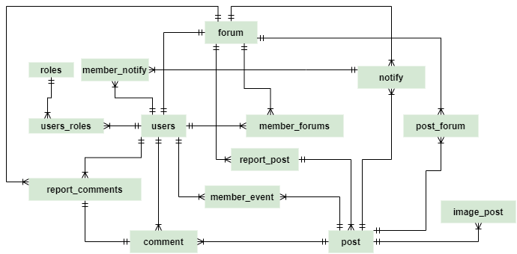  
  
*Picture 1: Entity Relationship Diagram 1*  
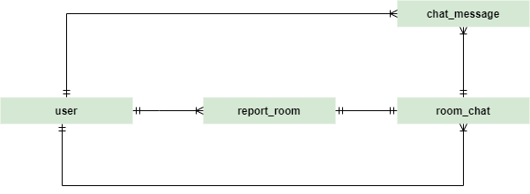  
*Picture 2: Entity Relationship Diagram 2*



*Picture 3: Lengend Entity Relationship Diagram*

* 1. **Table Diagram**

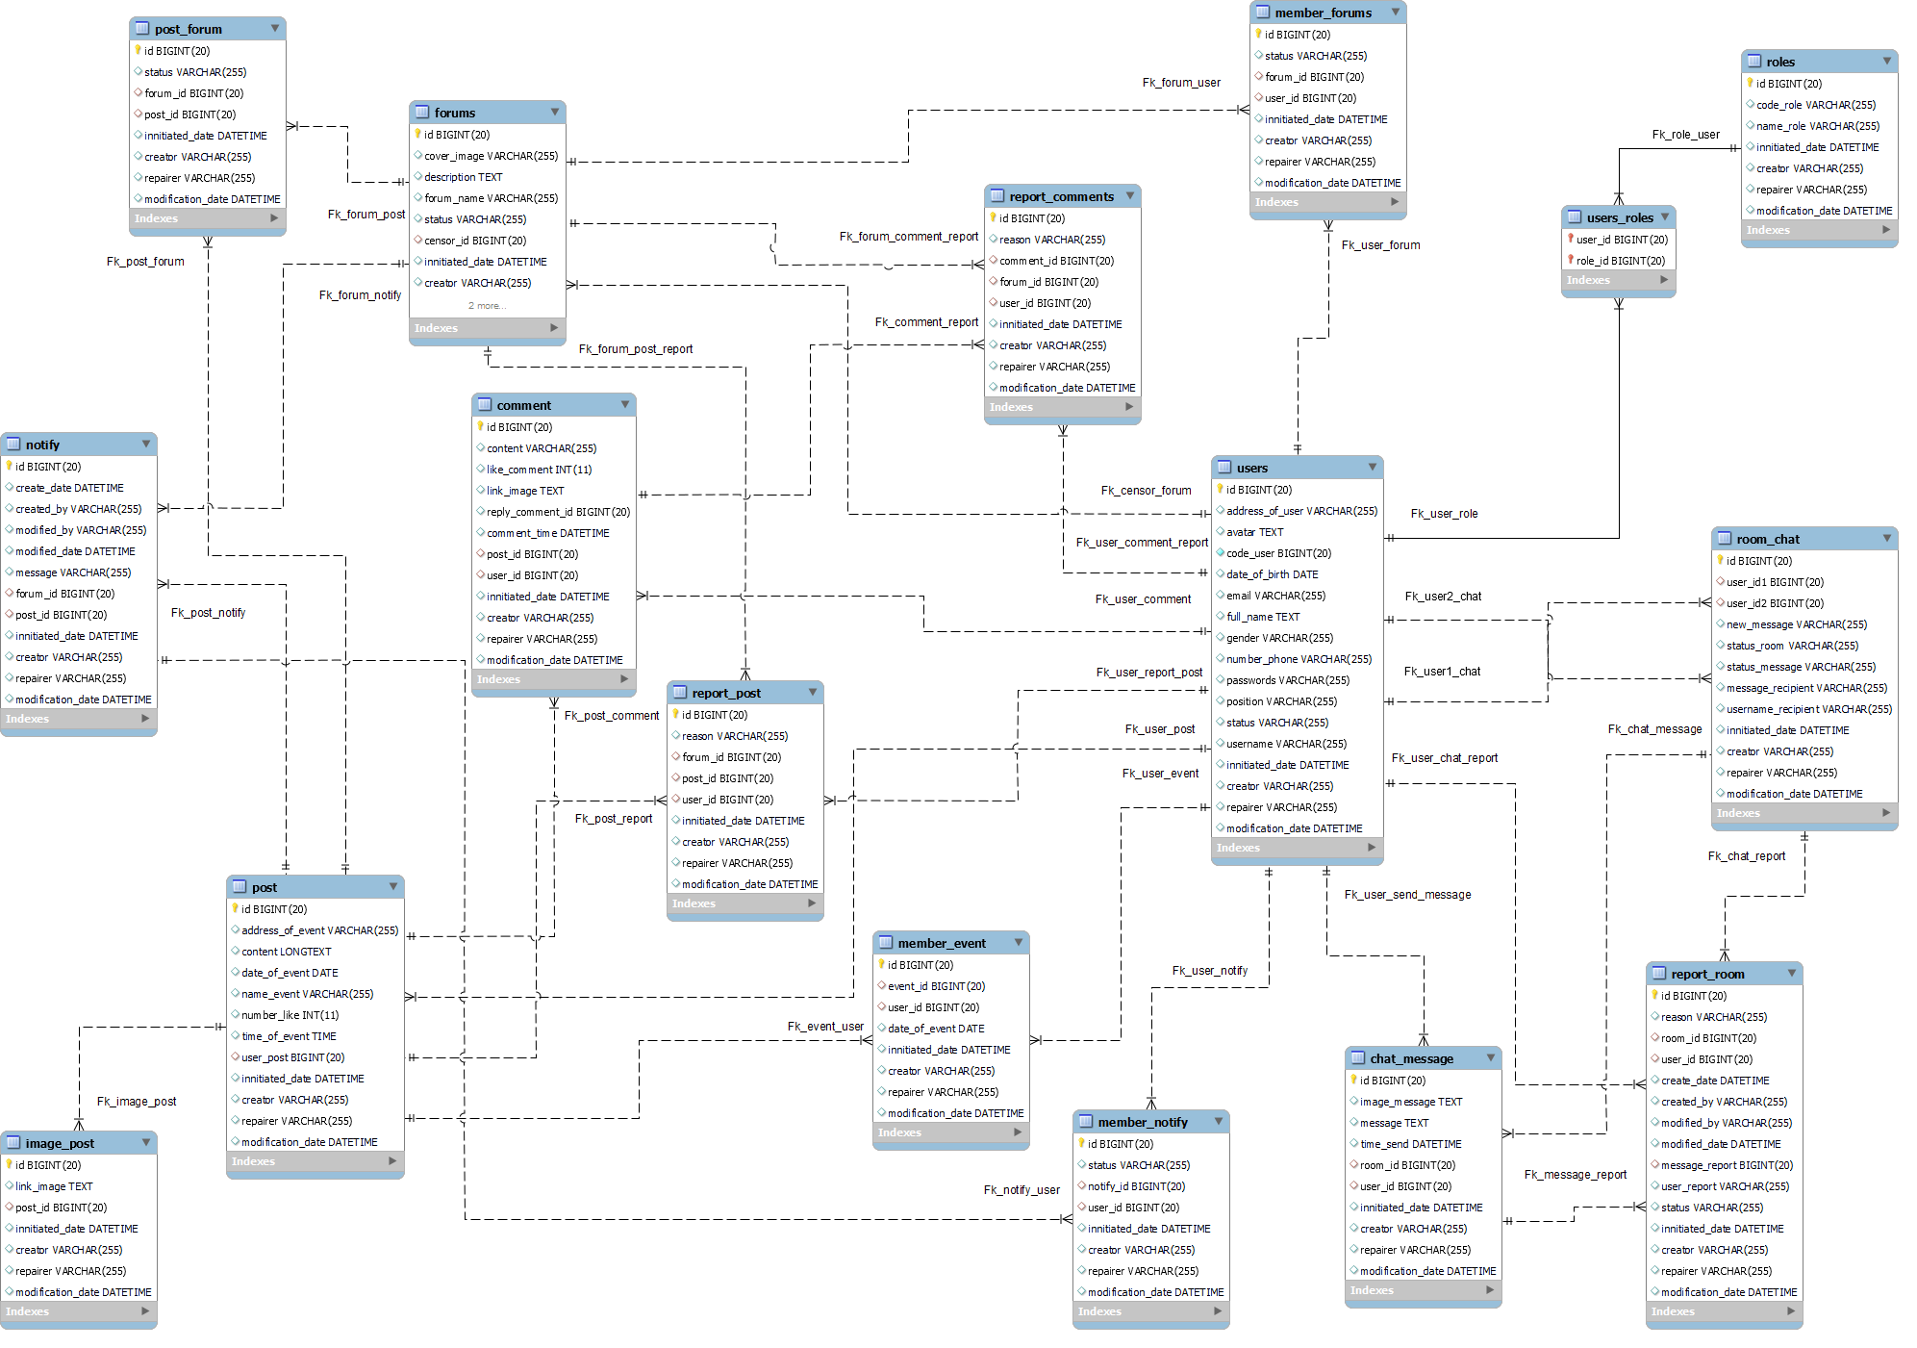 *Picture 4: Table Diagram*

1. **Table Details**

* ***Table 01: user***

|  |  |  |  |  |
| --- | --- | --- | --- | --- |
| **ID** | **Field** | **Type** | **Constraint** | **Description** |
| **1** | id | BIGINT | Primary key | User id |
| **2** | innitiated_date | DATETIME |  | Data initialization date |
| **3** | creator | VARCHAR (255) |  | Data originator |
| **4** | repairer | VARCHAR (255) |  | Data editor |
| **5** | modification_date | DATETIME |  | Data modification date |
| **6** | code_user | BIGINT (20) | Unique | User code |
| **7** | username | VARCHAR (255) | Unique | Username for login |
| **8** | password | VARCHAR (255) |  | Password for login |
| **9** | email | VARCHAR (255) | Unique | Email of user |
| **10** | full_name | VARCHAR (255) |  | Full name of the user |
| **11** | gender | VARCHAR (255) |  | Gender of user |
| **13** | date_of_birth | DATE |  | Date of birth of the user |
| **14** | avatar | TEXT |  | Avatar of user |
| **15** | number_phone | VARCHAR (255) |  | Number phone of the user |
| **16** | position | VARCHAR (255) |  | Position of user |
| **17** | status | VARCHAR (255) |  | Status of a user in the system |

* ***Table 02:*** ***users_roles***

|  |  |  |  |  |
| --- | --- | --- | --- | --- |
| **ID** | **Field** | **Type** | **Constraint** | **Description** |
| **1** | user_id | BIGINT (20) | Primary key, Foreign key (user) | Id of user |
| **2** | role_id | BIGINT (20) | Primary key, Foreign key (user) | Id of role |

* ***Table 03:*** ***roles***

|  |  |  |  |  |
| --- | --- | --- | --- | --- |
| **ID** | **Field** | **Type** | **Constraint** | **Description** |
| **1** | id | BIGINT (20) | Primary key | Role id |
| **2** | innitiated_date | DATETIME |  | Data initialization date |
| **3** | creator | VARCHAR (255) |  | Data originator |
| **4** | repairer | VARCHAR (255) |  | Data editor |
| **5** | modification_date | DATETIME |  | Data modification date |
| **6** | code_role | VARCHAR (255) |  | Code of role |
| **7** | name_role | VARCHAR (255) |  | Name of role |

* ***Table 04: forums***

|  |  |  |  |  |
| --- | --- | --- | --- | --- |
| **ID** | **Field** | **Type** | **Constraint** | **Description** |
| **1** | id | BIGINT (20) | Primary key | Forum id |
| **2** | innitiated_date | DATETIME |  | Data initialization date |
| **3** | creator | VARCHAR (255) |  | Data originator |
| **4** | repairer | VARCHAR (255) |  | Data editor |
| **5** | modification_date | DATETIME |  | Data modification date |
| **6** | forum_name | VARCHAR (255) | Unique | Name of forum |
| **7** | description | TEXT |  | Description of forum |
| **8** | cover_image | TEXT |  | Cover image of the forum |
| **9** | status | VARCHAR (255) |  | Status of forum |
| **10** | censor_id | VARCHAR (255) | Foreign key (user) | The user id of the censor manage forum |

* ***Table 05: member_forums***

|  |  |  |  |  |
| --- | --- | --- | --- | --- |
| **ID** | **Field** | **Type** | **Constraint** | **Description** |
| **1** | id | INT (20) | Primary key | Role id |
| **2** | innitiated_date | DATETIME |  | Data initialization date |
| **3** | creator | VARCHAR (255) |  | Data originator |
| **4** | repairer | VARCHAR (255) |  | Data editor |
| **5** | modification_date | DATETIME |  | Data modification date |
| **7** | forum_id | BIGINT (20) | Foreign key (forums) | Id of forums |
| **8** | user_id | BIGINT (20) | Foreign key (user) | Id of user |
| **9** | status | VARCHAR (255) |  | Status of member |

* ***Table 06: post***

|  |  |  |  |  |
| --- | --- | --- | --- | --- |
| **ID** | **Field** | **Type** | **Constraint** | **Description** |
| **1** | id | BIGINT (20) | Primary key | Post id |
| **2** | innitiated_date | DATETIME |  | Data initialization date |
| **3** | creator | VARCHAR (255) |  | Data originator |
| **4** | repairer | VARCHAR (255) |  | Data editor |
| **5** | modification_date | DATETIME |  | Data modification date |
| **6** | content | LONG TEXT |  | Content in post |
| **7** | address_of_event | VARCHAR (255) |  | Address of event in the post |
| **8** | date_of_event | DATE |  | Date of the event in the post |
| **9** | number_like | INT (11) |  | Number of like in post |
| **10** | user_id | BIGINT (20) | Foreign key (user) | Id of user create a post |

* ***Table 07: image_post***

|  |  |  |  |  |
| --- | --- | --- | --- | --- |
| **ID** | **Field** | **Type** | **Constraint** | **Description** |
| **1** | id | BIGINT (20) | Primary key | Image id |
| **2** | innitiated_date | DATETIME |  | Data initialization date |
| **3** | creator | VARCHAR (255) |  | Data originator |
| **4** | repairer | VARCHAR (255) |  | Data editor |
| **5** | modification_date | DATETIME |  | Data modification date |
| **6** | link_image | VARCHAR (255) |  | Link image of the post |
| **7** | post_id | BIGINT (20) | Foreign key (post) | Id of post |

* ***Table 08: post_forum***

|  |  |  |  |  |
| --- | --- | --- | --- | --- |
| **ID** | **Field** | **Type** | **Constraint** | **Description** |
| **1** | id | BIGINT (20) | Primary key | Id post in a forum |
| **2** | innitiated_date | DATETIME |  | Data initialization date |
| **3** | creator | VARCHAR (255) |  | Data originator |
| **4** | repairer | VARCHAR (255) |  | Data editor |
| **5** | modification_date | DATETIME |  | Data modification date |
| **6** | forum_id | BIGINT (20) | Foreign key (forums) | Id of forum |
| **7** | post_id | BIGINT (20) | Foreign key (post) | Id of post |
| **8** | status | VARCHAR (255) |  | Status post in a forum |

* ***Table 09: comment***

|  |  |  |  |  |
| --- | --- | --- | --- | --- |
| **ID** | **Field** | **Type** | **Constraint** | **Description** |
| **1** | id | BIGINT (20) | Primary key | Id comment |
| **2** | innitiated_date | DATETIME |  | Data initialization date |
| **3** | creator | VARCHAR (255) |  | Data originator |
| **4** | repairer | VARCHAR (255) |  | Data editor |
| **5** | modification_date | DATETIME |  | Data modification date |
| **6** | content | VARCHAR (255) |  | Content of comment |
| **7** | like_comment | INT (11) |  | Like of comment |
| **8** | link_image | TEXT |  | Link image of comment |
| **9** | reply_comment_id | BIGINT (20) |  | Reply of comment |
| **10** | comment_time | DATE |  | Time comment |
| **11** | post_id | BIGINT (20) | Foreign key (post) | Id of post |
| **12** | user_id | BIGINT (20) | Foreign key (user) | Id of user comment |

* ***Table 10: member_event***

|  |  |  |  |  |
| --- | --- | --- | --- | --- |
| **ID** | **Field** | **Type** | **Constraint** | **Description** |
| **1** | id | BIGINT (20) | Primary key | Id comment |
| **2** | innitiated_date | DATETIME |  | Data initialization date |
| **3** | creator | VARCHAR (255) |  | Data originator |
| **4** | repairer | VARCHAR (255) |  | Data editor |
| **5** | modification_date | DATETIME |  | Data modification date |
| **6** | event_id | BIGINT (20) | Foreign key (post) | Id of post |
| **7** | user_id | BIGINT (20) | Foreign key (user) | Id of user comment |
| **8** | date_of_event | DATE |  | The date of the event will happen |

* ***Table 11: notify***

|  |  |  |  |  |
| --- | --- | --- | --- | --- |
| **ID** | **Field** | **Type** | **Constraint** | **Description** |
| **1** | id | BIGINT (20) | Primary key | Id comment |
| **2** | innitiated_date | DATETIME |  | Data initialization date |
| **3** | creator | VARCHAR (255) |  | Data originator |
| **4** | repairer | VARCHAR (255) |  | Data editor |
| **5** | modification_date | DATETIME |  | Data modification date |
| **6** | forum_id | BIGINT (20) | Foreign key (forum) | Id of forum |
| **7** | message | VARCHAR (255) |  | Message of notify |
| **8** | post_id | BIGINT (20) | Foreign key (post) | Id of post |

* ***Table 12: report_post***

|  |  |  |  |  |
| --- | --- | --- | --- | --- |
| **ID** | **Field** | **Type** | **Constraint** | **Description** |
| **1** | id | BIGINT (20) | Primary key | Id comment |
| **2** | innitiated_date | DATETIME |  | Data initialization date |
| **3** | creator | VARCHAR (255) |  | Data originator |
| **4** | repairer | VARCHAR (255) |  | Data editor |
| **5** | modification_date | DATETIME |  | Data modification date |
| **6** | post_id | BIGINT (20) | Foreign key (post) | Id of post reported |
| **7** | user_id | BIGINT (20) | Foreign key (user) | Id of user report |
| **8** | forum_id | BIGINT (20) | Foreign key (forum) | Id of the forum has post reported |
| **9** | reason | VARCHAR (255) |  | Reason of report |

* ***Table 13: report_comments***

|  |  |  |  |  |
| --- | --- | --- | --- | --- |
| **ID** | **Field** | **Type** | **Constraint** | **Description** |
| **1** | id | BIGINT (20) | Primary key | Id comment |
| **2** | innitiated_date | DATETIME |  | Data initialization date |
| **3** | creator | VARCHAR (255) |  | Data originator |
| **4** | repairer | VARCHAR (255) |  | Data editor |
| **5** | modification_date | DATETIME |  | Data modification date |
| **6** | comment_id | BIGINT (20) | Foreign key (comment) | Id of comment reported |
| **7** | user_id | BIGINT (20) | Foreign key (user) | Id of user report |
| **8** | forum_id | BIGINT (20) | Foreign key (forum) | Id of the forum have comments reported |
| **9** | reason | VARCHAR (255) |  | Reason of report |

* ***Table 14: member_notify***

|  |  |  |  |  |
| --- | --- | --- | --- | --- |
| **ID** | **Field** | **Type** | **Constraint** | **Description** |
| **1** | id | BIGINT (20) | Primary key | Id comment |
| **2** | innitiated_date | DATETIME |  | Data initialization date |
| **3** | creator | VARCHAR (255) |  | Data originator |
| **4** | repairer | VARCHAR (255) |  | Data editor |
| **5** | modification_date | DATETIME |  | Data modification date |
| **6** | notify_id | BIGINT (20) | Foreign key (notify) | Id of notifying |
| **7** | user_id | BIGINT (20) | Foreign key (user) | Id of the user receiving the notice |
| **8** | status | VARCHAR (255) |  | Status of notifying the user has read or not |

* ***Table 15: room_chat***

|  |  |  |  |  |
| --- | --- | --- | --- | --- |
| **ID** | **Field** | **Type** | **Constraint** | **Description** |
| **1** | id | BIGINT (20) | Primary key | Id comment |
| **2** | innitiated_date | DATETIME |  | Data initialization date |
| **3** | creator | VARCHAR (255) |  | Data originator |
| **4** | repairer | VARCHAR (255) |  | Data editor |
| **5** | modification_date | DATETIME |  | Data modification date |
| **6** | status_room | VARCHAR (255) |  | Status of room chat |
| **7** | new_message | VARCHAR (255) |  | The latest message of room |
| **8** | user_id1 | BIGINT (20) | Foreign key (user) | Id of user one in-the-room chat |
| **9** | user_id2 | BIGINT (20) | Foreign key (user) | Id of user two in-the-room chat |
| **10** | status_message | VARCHAR (255) |  | Status of the new message, user have read or not |
| **11** | username_recipient | VARCHAR (255) |  | Username of the recipient message |

* ***Table 16: report_room***

|  |  |  |  |  |
| --- | --- | --- | --- | --- |
| **ID** | **Field** | **Type** | **Constraint** | **Description** |
| **1** | id | BIGINT (20) | Primary key | Id comment |
| **2** | innitiated_date | DATETIME |  | Data initialization date |
| **3** | creator | VARCHAR (255) |  | Data originator |
| **4** | repairer | VARCHAR (255) |  | Data editor |
| **5** | modification_date | DATETIME |  | Data modification date |
| **6** | room_id | BIGINT (20) | Foreign key (room_chat) | Id of room chat reported |
| **7** | user_id | BIGINT (20) | Foreign key (user) | Id of user report room chat |
| **8** | reason | VARCHAR (255) |  | Reason of report |
| **9** | message_report | VARCHAR (255) |  | Message reported |
| **10** | userReport | VARCHAR (255) |  | Reported person |
| **11** | status | VARCHAR (255) |  | Status of the report |
| **12** | message_recipient | VARCHAR (255) |  | The user receives a new message |

* ***Table 17: chat_message***

|  |  |  |  |  |
| --- | --- | --- | --- | --- |
| **ID** | **Field** | **Type** | **Constraint** | **Description** |
| **1** | id | BIGINT (20) | Primary key | Id comment |
| **2** | innitiated_date | DATETIME |  | Data initialization date |
| **3** | creator | VARCHAR (255) |  | Data originator |
| **4** | repairer | VARCHAR (255) |  | Data editor |
| **5** | modification_date | DATETIME |  | Data modification date |
| **6** | image_chat | TEXT |  | Link image user send |
| **7** | message | TEXT |  | Message user send in-the-room chat |
| **8** | room_id | BIGINT (20) | Foreign key (room_chat) | Id of room chat |
| **9** | user_id | BIGINT (20) | Foreign key (user) | Id of user send message |

1. **Firebase JSON Structure**

**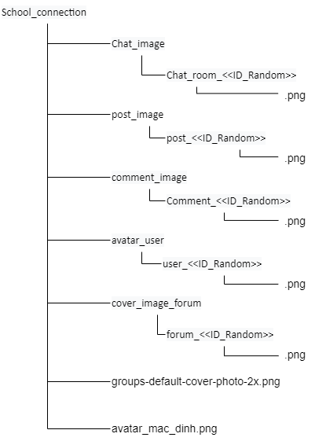***Figure 4: Firebase JSON Structure*

* 1. **Details**
* ***Table 19: Details firebase Structure***

|  |  |
| --- | --- |
| **Folder** | **Description** |
| Chat_room<<ID_Random>> | The folder contains an image in the chat |
| Comment_<<ID_Random>> | The folder contains an image in the comment |
| post_<<ID_Random>> | The folder contains an image in the post |
| user_<<ID_Random>> | The folder contains an image in the avatar user |
| forum_<<ID_Random>> | The folder contains an image in the cover image of the forum |
| avatar_mac_dinh.png | default image of user avatar |
| groups-default-cover-photo-2x.png | default image of the cover image in the forum |